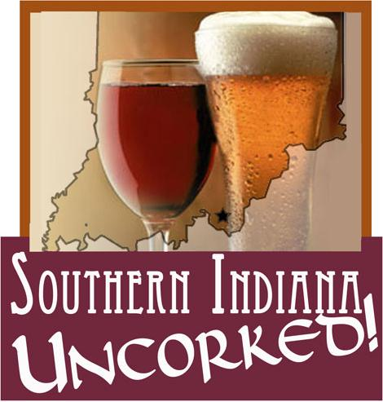
2010 Sponsorship Levels

$5,000 – Official Sponsor
-Recognition before each entertainment act
-Free booth space
-Free VIP admission for 10
-Company logo on all marketing materials
-Full page ad in festival program
-Logo on tasting glasses & wristbands

$1,000 - Diamond
-Recognition before each entertainment act
-Free booth space
-Free VIP admission for 10
-Company logo on all marketing materials
-Full page ad in festival program

$500 - Platinum
-Free booth space
-Free VIP admission for 5
-Company logo on all marketing materials
-1/2 page ad in festival program

$250 - Gold
-Free regular admission for 5
-Company logo on website
-Small ad in festival program

$100 - Silver
-Free regular admission for 2
-Company logo on website
-Small ad in festival program

$50 - Bronze
-Free regular admission for 1
-Listing in festival program

In-Kind Donations
-In-kind donations will be considered based on a 2 to 1 ratio compared with standard cash sponsorship. For example, an in kind donation valued at $5,000 would receive the sponsorship benefits afforded a $2,500 cash sponsor.

Underwriting Sponsors
Parking (Exclusive) - $100
-Company banner will be displayed at entrance to the parking area
-Company will be recognized during event via 2 PA announcements
-Company name will appear in the program

Entertainment (Exclusive) - $500
-Company banner will be prominently displayed on stage
-Company will be recognized during event via 2 PA announcements
-Company name will appear in the program

Information Booth (Exclusive) - $100.00
-Company banner prominently displayed on booth
-Company will be recognized during event via 2 PA announcements
-Company name will appear in the program

Wine & Beer Pavilion (Exclusive) - $500.00
-Company banner prominently displayed in the Wine & Beer Pavilion
-Company will be recognized during event via 2 PA announcements
-Company name will appear in the program

Exclusive sponsorships will be first come, first served.

Please complete the form below and return with payment, company logo & information for advertisements.

Sponsor Name____________________________________________________________________

Address _________________________________________________________________________

Sponsorship Area/Level _____________________________

